**INDEX**

**G SUITE** 3

**MICROSOFT AZURE** 9

**AWS CLOUD** 15

**VMWare Cloud** 26

**MEGHRAJ** 31

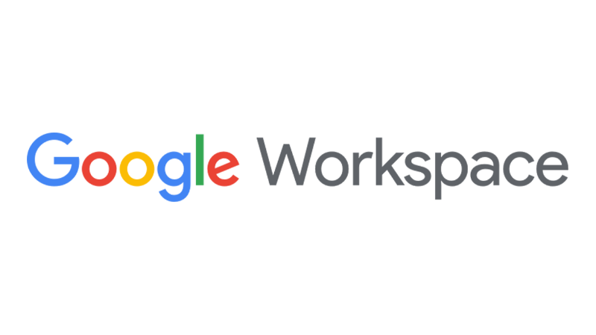

# **(G SUITE)**

Google Workspace (formerly known as "G Suite") is a brand of cloud computing, productivity and collaboration tools, software and products developed by Google. It was first launched in 2006 as Google Apps for Your Domain and rebranded as G Suite in 2016.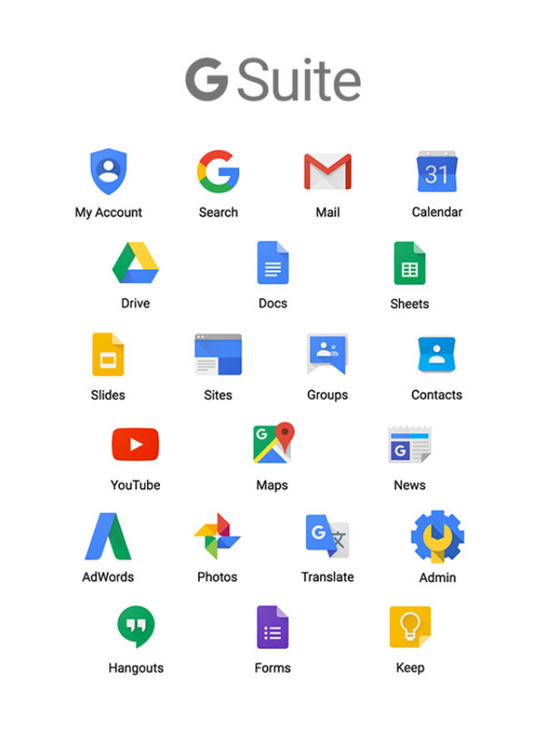



G Suite is used:

● for communication – Gmail, Hangouts, Calendar, and Google+

● for collaboration – Docs, Sheets, Slides, Forms, and Sites

● for storage – Drive

● for managing users and services – Admin panel and Vault.

Furthermore, G Suite adds enterprise features such as custom email addresses at a domain, unlimited cloud storage, additional administrative tools and advanced settings, as well as 24/7 phone and email support.

The Cloud is really a physical infrastructure with several servers that operate over the Internet to provision services or software with minimal effort. There are three types of cloud services: **IaaS, PaaS and SaaS**.

Software as a Service is the most popular of the cloud computing models. It’s services are provided over the Internet. **Gsuite (also known as Google Apps) is an example of SaaS**.

**How does G Suite work?**

As mentioned earlier, G Suite is a SaaS application. These apps are accessible remotely, over the Internet. Some of the apps included in G Suite are:

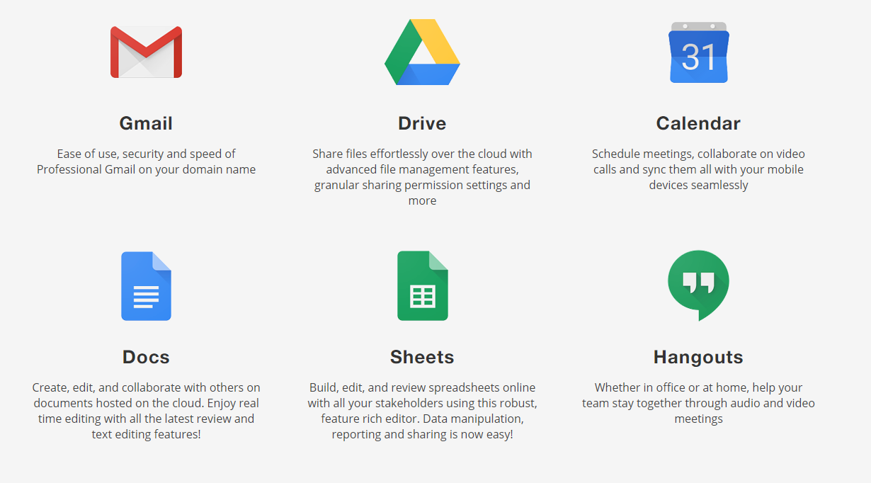

Once a company or a business buys a G Suite package, they can use these apps to work better, faster & easier as a team by sharing documents, scheduling meetings on Calendars, meeting together on Hangouts & more.

**Why G Suite for Businesses?**

G Suite is especially suited for businesses due to the sheer nature of companies – large team members, multiple collaborations, daily communications & more.

**Key benefits of using Google Workspace**

* Access all Google apps at anytime, anywhere from a computer, tablet or phone.
* Use the Google Admin Console to manage all company data, mobile devices, email addresses, and security settings.
* Organize meetings more efficiently by scheduling events in a shared calendar, sending reminders to Gmail, join video meetings with Hangouts and share presentations with Slides.
* Create online documents, spreadsheets, surveys & forms, and presentations.
* Share, collaborate and comment on text documents, presentations, and spreadsheets using Google Drive.
* Use Google Vault for archiving emails and chats, e-discovery of information and export of emails and chats.

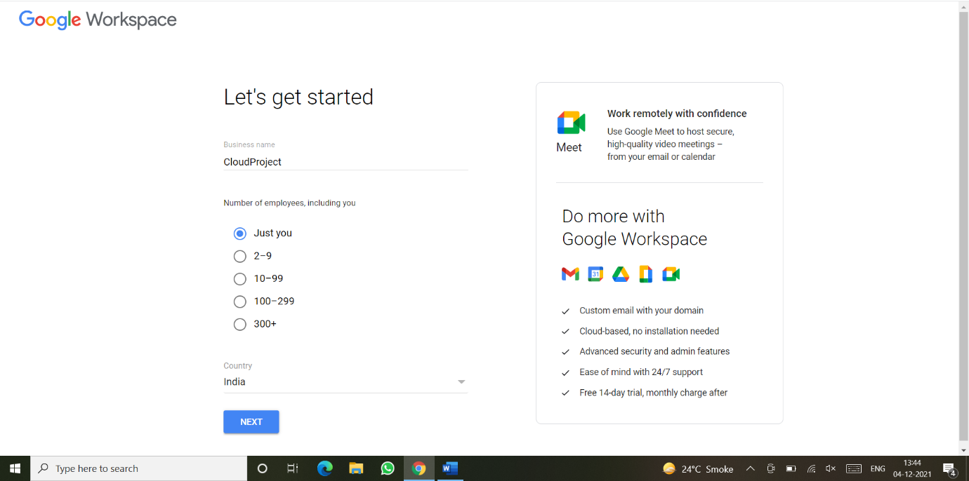

*Google Workspace account set up page*

All the files/data on various G Suite products like Docs, Slides, Drive etc. are stored on Google Cloud and can be achieved by the user anywhere from any device having an internet connection.

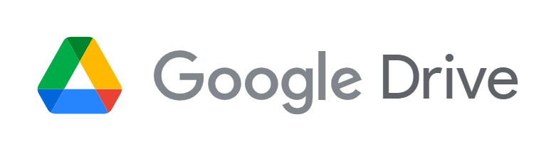

**Google Drive**

Google Drive is a popular, **free cloud storage solution** for file storage and synchronization developed by Google. It is one of the most trusted cloud storage providers today built on the top of Google Cloud storage. **Google Drive is Google’s SaaS offerings** for general users to store file. It provides the capability and convenience of storing and accessing files anywhere and anytime using the cloud technology. Users can access their stored data from anywhere and share it effortlessly with other Google Drive users. It also offers access to free web-based applications for creating documents and spreadsheets. It acts as the default storage for Gmail or Google Docs and provides easy and convenient transfer of data from your personal computer to the cloud. It efficiently integrates with other Google services.

Google Drive encompasses Google Docs, Google Sheets, and Google Slides, which are a part of the Google Docs Editors office suite that permits collaborative editing of documents, spreadsheets, presentations, drawings, forms, and more. **Google Drive is a key component of Google Workspace**, Google's monthly subscription offering for businesses and organizations that operated as G Suite until October 2020.

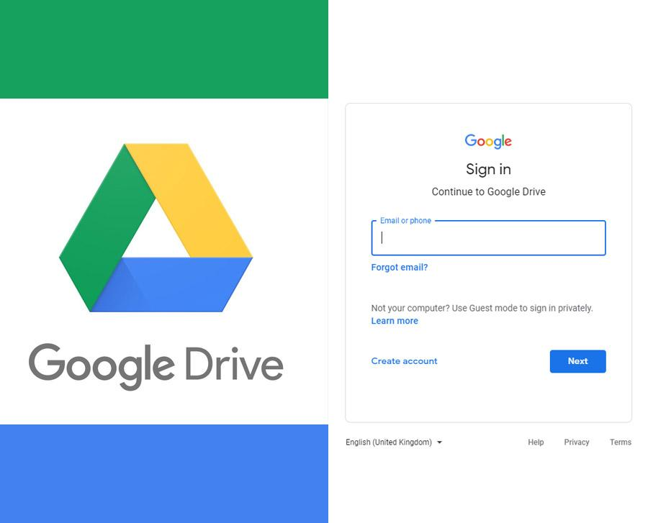

*Google Drive’s*

*login page*

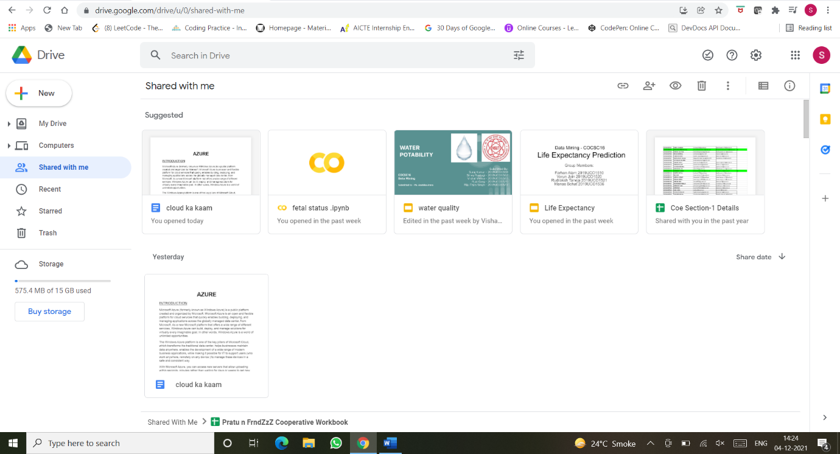

*Google Drive’s home page*

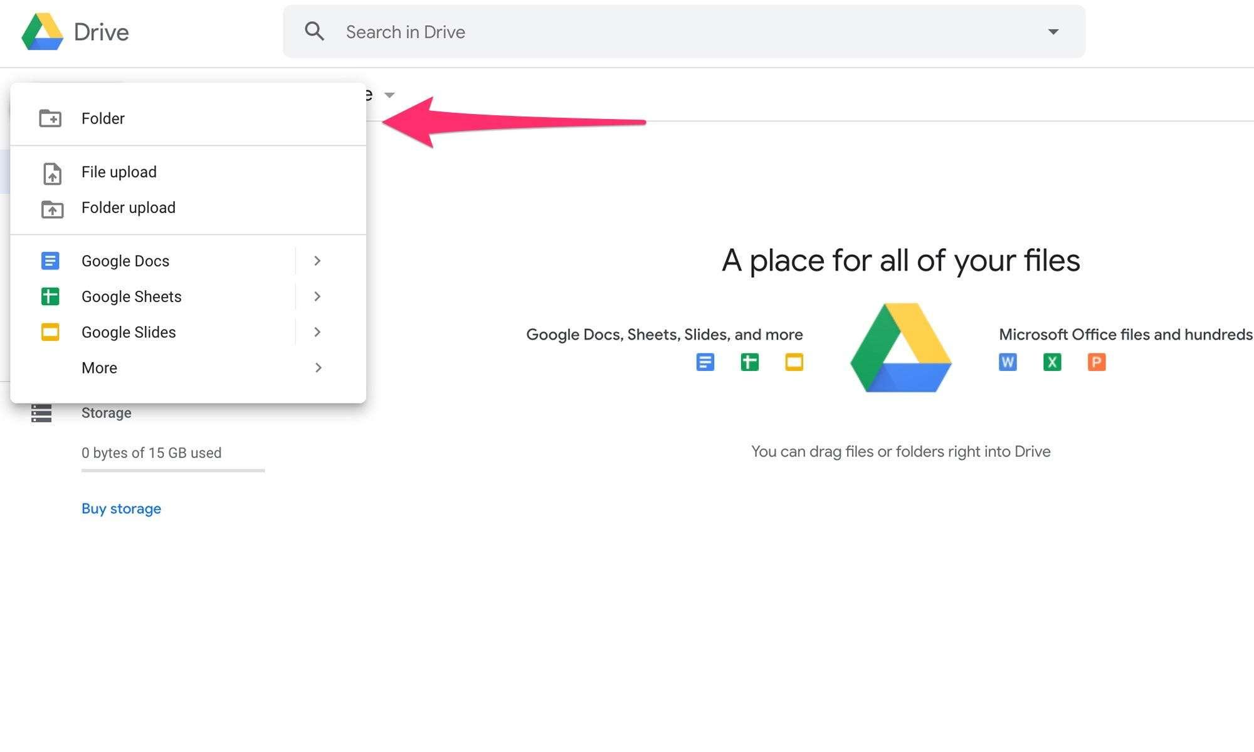

*Managing files and folders on drive*

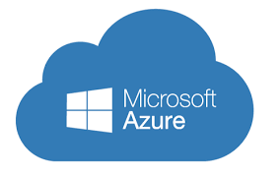

# **MICROSOFT AZURE**

Microsoft Azure (formerly known as Windows Azure) is a public platform created and organized by Microsoft. Microsoft Azure is an open and flexible platform for cloud services that quickly enables building, deploying, and managing applications across the globally managed data center, from Microsoft. As a new Microsoft platform that offers a wide range of different services, Windows Azure can build, deploy, and manage solutions for virtually every imaginable goal. In other words, Windows Azure is a world of unlimited opportunities.

The Windows Azure platform is one of the key pillars of Microsoft Cloud, which transforms the traditional data center, helps businesses maintain data anywhere, enables the development of a wide range of modern business applications, while making it possible for IT to support users (who work anywhere, remotely on any device ) to manage these devices in a safe and consistent way.

With Microsoft Azure, you can access new servers that allow uploading within seconds, minutes rather than waiting for days or weeks to get new hardware in one's data center. In most cases, many Azure actions are performed automatically without human involvement, nor interaction.

**Windows Azure Services**

Cloud-based Windows Azure Services are:

1. Computer services

2. Network Services

3. Data services

4. Application Services

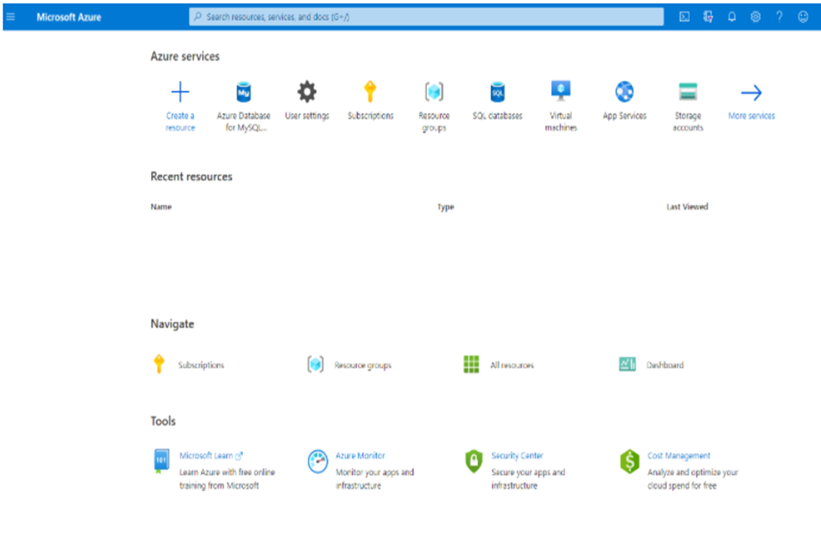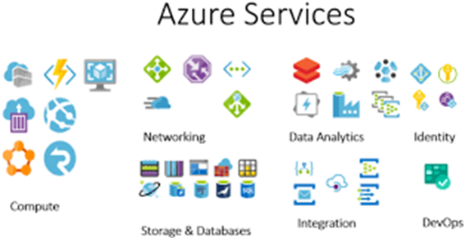

*Azure Home page*

**Computer Services**

Azure Computer Services provide the power needed to process applications that will run on the cloud.

Windows Azure currently offers four different services:

· Virtual machines - This service provides a general-purpose environment that allows to create, deploy, and manage virtual machines in the Windows Azure cloud.

· Web sites - This service provides a managed network environment that can be used to create new web pages or to send existing business clouds to your site.

· Cloud services - This service enables building and deploying low-cost administration applications using almost any programming language.

· Mobile services - This service provides a solution for building and deploying applications and storing data on mobile devices.

**Virtual machines**

Azure's Virtual Machines (VMs) are one of the major functions of Azure's IaaS capabilities along with Virtual Networks. Virtual Machines support the use of a Windows or Linux server in the Microsoft Azure database. There is full control of VM configuration here. Azure Virtual Machines allow the creation and use of virtual machines in the cloud. By providing the what is known as "Infrastructure as a Service (IaaS)", virtual machine technology can be used in various ways including:

- Virtual development and testing machines

- Executing cloud applications

- Expanding the cloud data center - Treatment of critical data in case of disaster in business

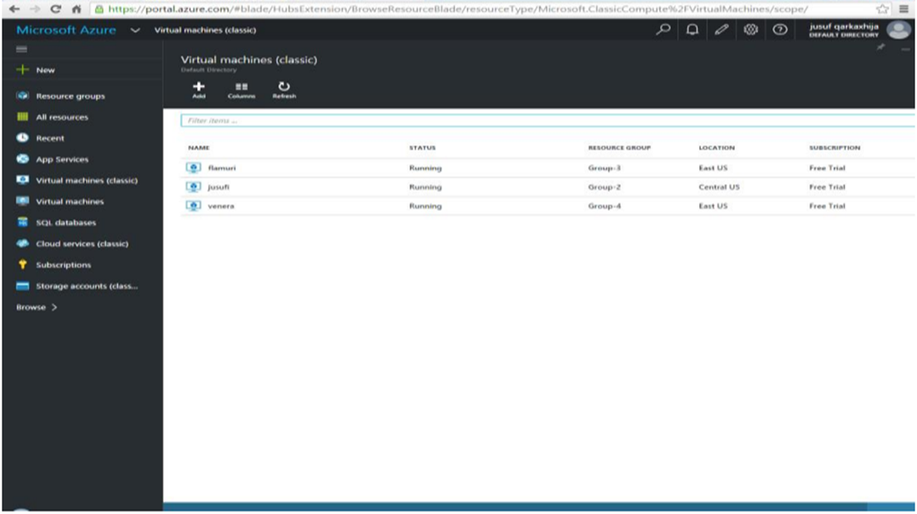

*Creating a virtual machine*

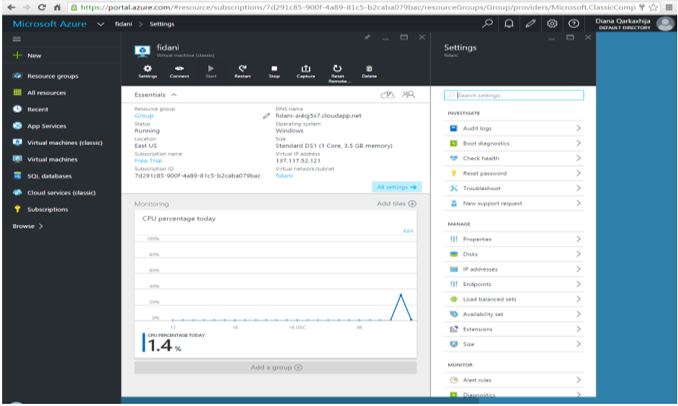

*Virtual machine created*

**Data Management**

Windows Azure, SQL Azure, and the associated services provide opportunities for storing and managing data in a range of ways. The following data management services and features are available:

* **Azure Storage:** This provides four core services for persistent and durable data storage in the cloud. The services support a REST interface that can be accessed from within Azure-hosted or on-premises (remote) applications.

The four storage services are:

* + **The Azure Table Service** provides a table-structured storage mechanism based on the familiar rows and columns format, and supports queries for managing the data.
  + **The Binary Large Object (BLOB) Service** provides a series of containers aimed at storing text or binary data.
  + **The Queue Service** provides a mechanism for reliable, persistent messaging between role instances, such as between a Web role and a Worker role.
  + **Windows Azure Drives** provide a mechanism for applications to mount a single volume NTFS VHD as a Page BLOB, and upload and download VHDs via the BLOB.
* **SQL Azure Database:** This is a highly available and scalable cloud database service built on SQL Server technologies, and supports the familiar T-SQL based relational database model. It can be used with applications hosted in Windows Azure.
* **Data Synchronization:** SQL Azure Data Sync is a cloud-based data synchronization service built on Microsoft Sync Framework technologies. It provides bi-directional data synchronization and data management capabilities allowing data to be easily shared between multiple SQL Azure databases and between on-premises and SQL Azure databases.
* **Caching:** This service provides a distributed, in-memory, low latency and high throughput application cache service that requires no installation or management, and dynamically increases and decreases the cache size automatically as required.

**Networking Services**

Windows Azure provides several networking services that you can take advantage of to maximize performance, implement authentication, and improve manageability of your hosted applications. These services include the following:

· **Content Delivery Network (CDN):** The CDN allows you to cache publicly available static data for applications at strategic locations that are closer (in network delivery terms) to end users.

· **Virtual Network Connect.** This service allows you to configure roles of an application running in Windows Azure and computers on your on-premises network so that they appear to be on the same network.

· **Virtual Network Traffic Manager.** This is a service that allows you to set up request redirection and load balancing based on three different methods. Alternative load balancing methods available are Failover and Round Robin.

· **Access Control.** This is a standards-based service for identity and access control that makes use of a range of identity providers that can authenticate users.

· **Service Bus.** This provides a secure messaging and data flow capability for distributed and hybrid applications, such as communication between Windows Azure hosted applications and on-premises applications and services, without requiring complex firewall and security infrastructures.

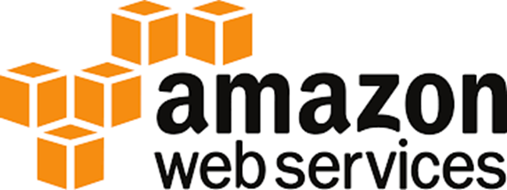

# **AWS CLOUD**

**INTRODUCTION**

The Amazon Web Services (AWS) is a set (more than 25) of proprietary web-based services owned by Amazon.com. All these services ranging from simple storage to sophisticated database services constitute the cloud platform offered by Amazon. An extensive list of customers for AWS include Dropbox, UniLever, Airbnb, Nasdaq, Netflix. As of 2007, there are more than 300K developers actively using AWS [1]. It is one of the pioneers which brought the cloud computing closer to masses helping number of startups bootstrap their businesses.

**HISTORY OF AWS CLOUD**

The Amazon web services was launched in 2002 and the portfolio of services expanded over time. The Amazon Elastic Cloud EC2 was built in 2004, which is central to the whole AWS infrastructure. Amazon itself is one of the clients for the EC2 platform. Amazon Virtual Private Cloud (Amazon VPC) is the latest (2011 August) addition to the list.

In spite of strong guarantees on the availability of the infrastructure to the clients, AWS experienced major outage recently, thus strengthening the critics of cloud computing initiatives. Today, AWS has a wide set of products including the following most popular ones.

1. Amazon Elastic Compute Cloud (EC2)

2. Amazon SimpleDB

3. Amazon DynamoDB

4. Amazon Relational Database Service (RDS)

5. Amazon Simple Storage Service (S3)

The less known ones are:

1. Amazon AWS Authentication

2. Amazon CloudFront

3. Amazon CloudWatch

4. Amazon Elastic-Cache

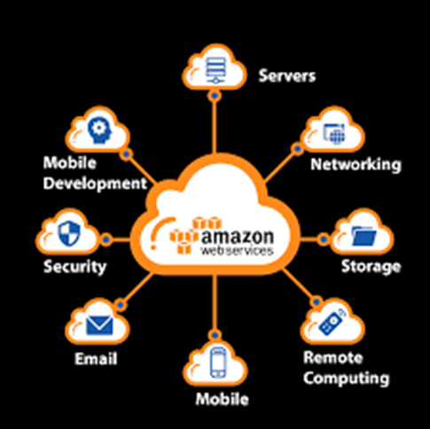

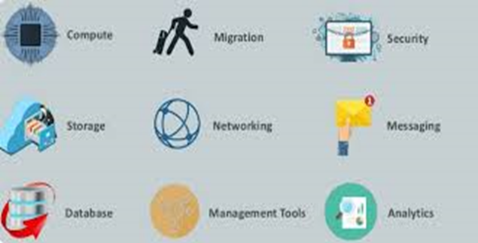

**WHY AWS??**

Being one of the early players in the cloud computing market, Amazon has a huge lead time in AWS marketing. Since designing and building huge cloud infrastructures require a vast number of resources: time, man power in terms of software engineering, competitors need precious time to catch up.

One of the major impacts of AWS on the business world is consumerization of businesses. Especially the following characteristics of AWS (or in general, any cloud computing infrastructure) made this possible:

· **On-demand service provisioning:** Entrepreneurs can set up their IT- based businesses whenever they wish and close it down when they decide to cease the business. The AWS gives unprecedented agility to entrepreneurs to test ideas/businesses without a lot invested in IT equipment, resource first and later struggling to get rid of.

· **Elasticity:** Some businesses may have very few customers to begin with, which may grow exponentially as the service offered becomes more interesting like in the case of Instagram. AWS provides an amazing way of elasticity which scales up and down the number of resources the current workload of a service demands.

· **Inexpensive:** In addition to the above, the services provided by AWS come at a fraction of cost involved in self-hosting of the services. Total cost of ownership of certain products (for example, Oracle Server) may be prohibitively expensive.

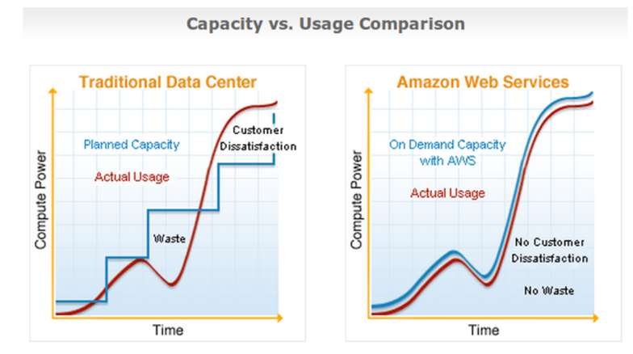· **Zero or negligible IT labor costs:** Resorting to AWS frees the businesses from setting up elaborate dedicated IT teams taking care of machine repairs, setting up and monitoring the energy resources.

*Fig. Cost Saving with AWS for business*

**AMAZON EC2(Computing Engine)**

Amazon Elastic Compute Cloud (Amazon EC2) is a web service that provides secure, resizable compute capacity in the cloud. It is designed to make web-scale cloud computing easier for developers. Amazon EC2’s simple web service interface allows you to obtain and configure capacity with minimal friction. It provides you with complete control of your computing resources and lets you run on Amazon’s proven computing environment.

Amazon EC2 offers the broadest and deepest compute platform with choice of processor, storage, networking, operating system, and purchase model. We offer the fastest processors in the cloud and we are the only cloud with 400 Gbps ethernet networking. We have the most powerful GPU instances for machine learning training and graphics workloads, as well as the lowest cost-per-inference instances in the cloud. More SAP, HPC, Machine Learning, and Windows workloads run on AWS than any other cloud.

· Reliable, scalable, infrastructure on demand:

· Secure compute for your applications

· Flexible options to optimize cost

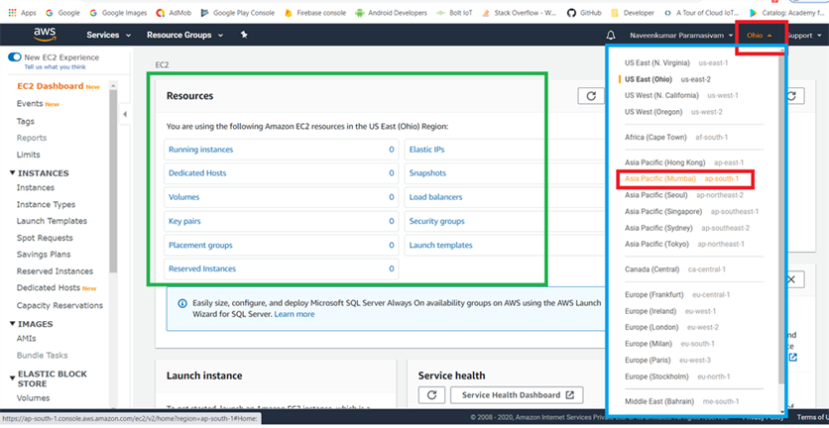· Easy to migrate and build apps

*Fig: Setup Amazon EC2 Windows Instances*

**BUILDING BLOCKS OF EC2s**

Amazon EC2 offers the broadest and deepest choice of instances, built on the latest compute, storage, and networking technologies and engineered for high performance and security.

· **Faster innovation and increased security with AWS Nitro System:** The [AWS Nitro System](https://aws.amazon.com/ec2/nitro/) is the underlying platform for our next generation of EC2 instances that offloads many of the traditional virtualization functions to dedicated hardware and software to deliver high performance, high availability, and high security while also reducing virtualization overhead. The Nitro System is a rich collection of building blocks that can be assembled in many different ways, giving us the flexibility to design and rapidly deliver new EC2 instance types with an ever-broadening selection of compute, storage, memory, and networking options.

· **Choice of processors:** A choice of latest generation [Intel Xeon](https://aws.amazon.com/intel/), [AMD EPYC](https://aws.amazon.com/ec2/amd/), and [AWS Graviton](https://aws.amazon.com/ec2/graviton/) CPUs enables you to find the best balance of performance and price for your workloads. EC2 instances powered by [NVIDIA GPUs](https://aws.amazon.com/nvidia/) and [AWS Inferentia](https://aws.amazon.com/machine-learning/inferentia/) are also available for workloads that require accelerated computing such as machine learning, gaming, and graphic intensive applications.

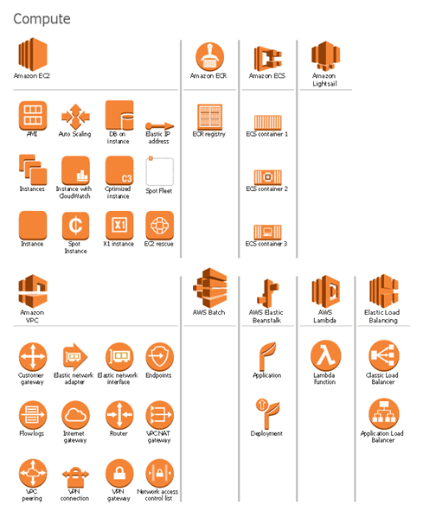· **High performance storage:** [Amazon Elastic Block Store](https://aws.amazon.com/ebs/) (EBS) provides easy to use, high performance block storage for use with Amazon EC2. Amazon EBS is available in a range of volume types that allow you to optimize storage performance and cost for your workloads. Many EC2 instance types also come with options for local NVMe SSD storage for applications that require low latency.

· **Enhanced networking:** AWS is the first and only cloud to offer 400 Gbps enhanced Ethernet networking for compute instances. [Enhanced networking](https://aws.amazon.com/ec2/faqs/) enables you to get significantly highest packet per second (PPS), lower network jitter, and lower latency. For high performance computing (HPC) applications.

· **Choice of purchasing model:** Amazon offers a choice of multiple purchasing models with On-Demand, [Spot Instances](https://aws.amazon.com/ec2/spot/), and [Savings Plan](https://aws.amazon.com/savingsplans/). With Spot Instances, you can save up to 90% for fault-tolerant workloads. With Savings Plan, you can save up to 72% savings with committed usage and flexibility across EC2, Fargate, and Lambda.

**AMAZON RELATIONAL DATABASE SERVICE(DATABASE)**

Amazon Relational Database Service (Amazon RDS) makes it easy to set up, operate, and scale a relational database in the cloud. It provides cost-efficient and resizable capacity while automating time-consuming administration tasks such as hardware provisioning, database setup, patching and backups. It frees you to focus on your applications so you can give them the fast performance, high availability, security and compatibility they need.

Amazon RDS is available on several [database instance types](https://aws.amazon.com/rds/instance-types/) - optimized for memory, performance or I/O - and provides you with six familiar database engines to choose from, including [Amazon Aurora](https://aws.amazon.com/rds/aurora/), [PostgreSQL](https://aws.amazon.com/rds/postgresql/), [MySQL](https://aws.amazon.com/rds/mysql/), [MariaDB](https://aws.amazon.com/rds/mariadb/), [Oracle Database](https://aws.amazon.com/rds/oracle/), and [SQL Server](https://aws.amazon.com/rds/sqlserver/). You can use the [AWS Database Migration Service](https://aws.amazon.com/dms/) to easily migrate or replicate your existing databases to Amazon RDS.

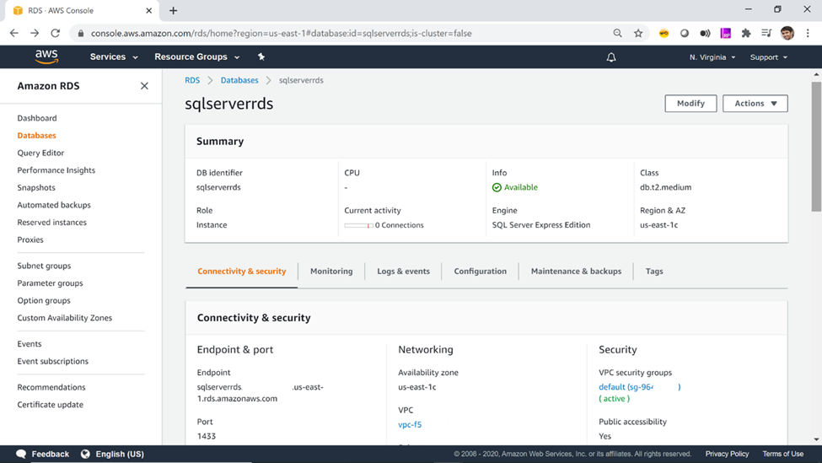

*Fig: Connecting AWS RDS SWL Server with AWS Glue*

**What makes Amazon RDS so effective?**

1. Lower administrative burden:

· Easy to use: You can use the [AWS Management Console](https://console.aws.amazon.com/rds/home), the [Amazon RDS Command Line Interface](https://docs.aws.amazon.com/cli/latest/reference/rds/), or simple [API calls](http://docs.aws.amazon.com/AmazonRDS/latest/APIReference/Welcome.html) to access the capabilities of a production-ready relational database in minutes. Amazon RDS database instances are pre-configured with parameters and settings appropriate for the engine and class you have selected..

2. Prediction

· General Purpose (SSD) Storage: Amazon RDS General Purpose Storage is an SSD-backed storage option delivers a consistent baseline of 3 IOPS per provisioned GB and provides the ability to burst up to 3,000 IOPS above the baseline. This storage type is suitable for a broad range of database workloads.

· Provisioned IOPS (SSD) Storage: Amazon RDS Provisioned IOPS Storage is an SSD-backed storage option designed to deliver fast, predictable, and consistent I/O performance.

3. Scalability

· Push-button compute scaling: You can scale the compute and memory resources powering your deployment up or down, up to a maximum of 32 vCPUs and 244 GiB of RAM. Compute scaling operations typically complete in a few minutes.

· Easy storage scaling: As your storage requirements grow, you can also provision additional storage. The Amazon Aurora engine will automatically grow the size of your database.

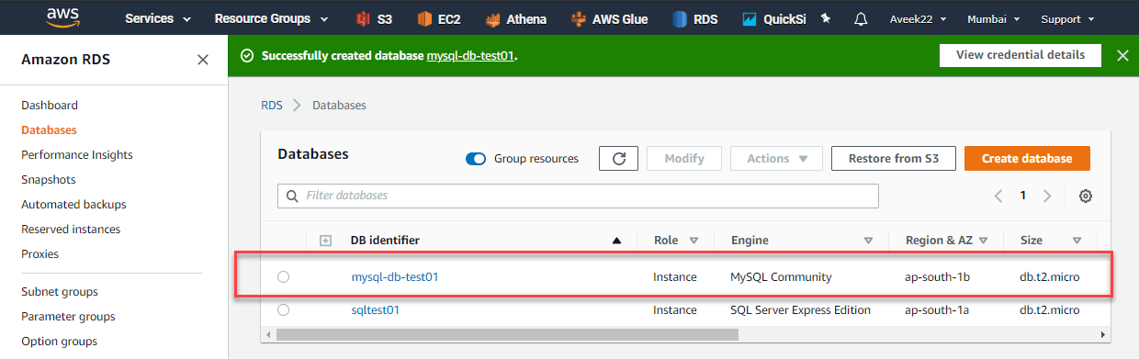

4. Security

· Encryption at rest and in transit: Amazon RDS allows you to encrypt your databases using keys you manage through [AWS Key Management Service (KMS)](https://aws.amazon.com/kms/). On a database instance running with Amazon RDS encryption, data stored at rest in the underlying storage is encrypted, as are its automated backups, read replicas, and snapshots.

· Network isolation: AWS recommends that you run your database instances in [Amazon VPC](https://aws.amazon.com/vpc/), which allows you isolate your database in your own virtual network and connect to your on-premises IT infrastructure using industry-standard encrypted IPsec VPNs..

5. Cost-effectiveness

· Pay only for what you use: There is no up-front commitment with Amazon RDS; you simply pay a monthly charge for each database instance that you launch. And, when you’re finished with a database instance, you can easily delete it. To see more details, visit the [Amazon RDS Instance Types](https://aws.amazon.com/rds/instance-types/) page and the [Amazon RDS Pricing](https://aws.amazon.com/rds/pricing/) page.

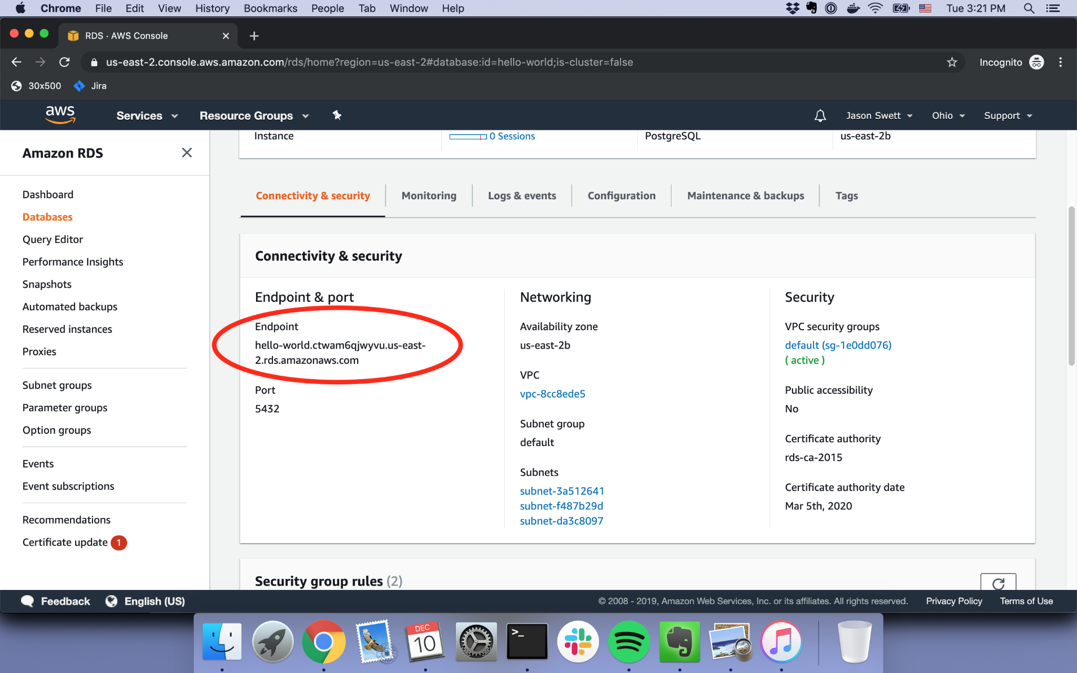

*Fig: Setting up an RDS database for Rails on EC-2 Code with Jason*

**AMAZON S3(Simply Storage Device)**

Amazon S3, at its core, facilitates object storage, providing leading scalability, data availability, security, and performance. Businesses of vast sizes can leverage S3 for storage and protect large sums of data for various use cases, such as websites, applications, backup, and more.

Amazon S3’s intuitive management features enable the frictionless organization of data and configurable access controls.

*Fig: Amazon S3 home page*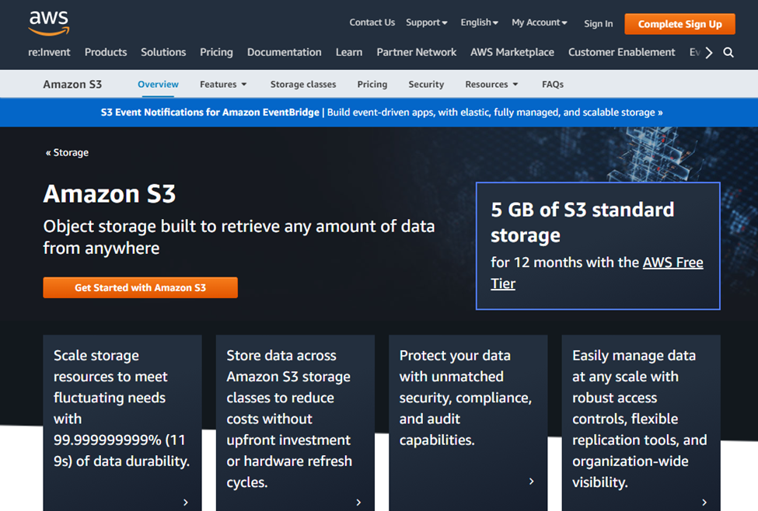

**How it works**

Amazon Simple Storage Service (Amazon S3) is an object storage service offering industry-leading scalability, data availability, security, and performance. Customers of all sizes and industries can store and protect any amount of data for virtually any use case, such as data lakes, cloud-native applications, and mobile apps. With cost-effective storage classes and easy-to-use management features, you can optimize costs, organize data, and configure fine-tuned access controls to meet specific business, organizational, and compliance requirements.

*Fig: Performance of different S3 storage classes* 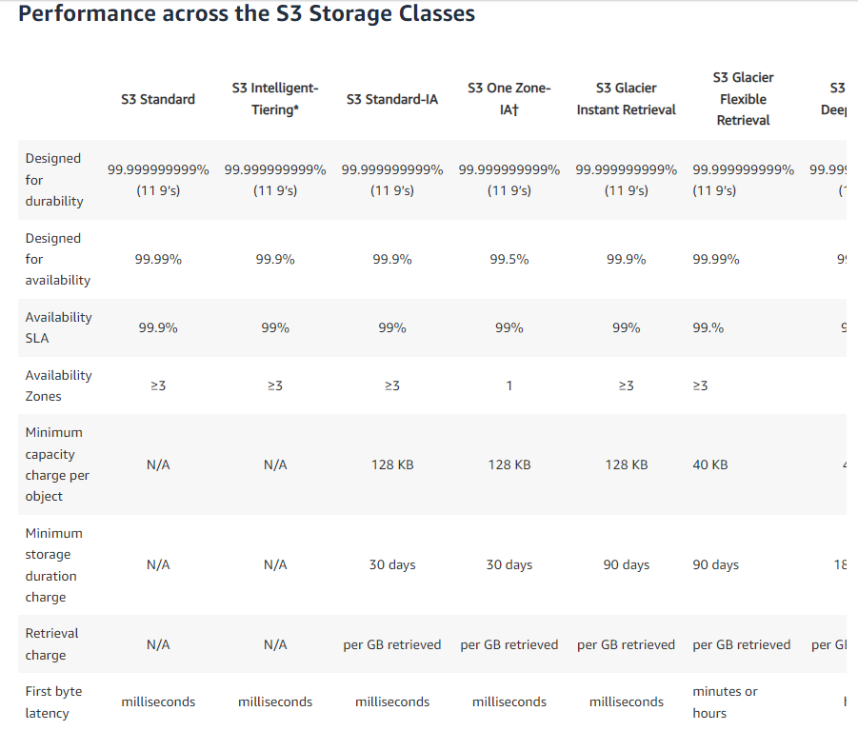

*Amazon S3 has various features you can use to organize and manage your data in ways that support specific use cases, enable cost efficiencies, enforce security, and meet compliance requirements. Data is stored as objects within resources called “buckets”, and a single object can be up to 5 terabytes in size. S3 features include capabilities to append metadata tags to objects, move and store data across the S3 Storage Classes, configure and enforce data access controls, secure data against unauthorized users, run big data analytics, monitor data at the object and bucket levels, and view storage usage and activity trends across your organization. Objects can be accessed through S3 Access Points or directly through the bucket hostname.*

**Other Different Amazon Services:**

1. AMAZON LAMBDA

Lambda permits you to run code without owning or managing servers. Users only pay for the compute time consumed.

Operate code for nearly any application or backend utility without administration. Users just upload the code, and Lambda does the rest, which provides precise software scaling and extensive availability.

1. AMAZON SNS(Simple Notification Services)

Amazon SNS is a fully managed messaging solution that provides low-cost infrastructure for bulk message delivery, primarily to mobile users. Users can chat directly with customers through system-to-system or app-to-person communication between decoupled microservice apps.

1. AMAZON EBS(Elastic Book Store)

Amazon Elastic Block Store (EBS) is a high-performance block storage solution used within Amazon EC2 for throughput and transaction workloads of any size, at any time. It handles a diverse range of workloads, such as relational and non-relational databases, and enterprise applications.

1. AMAZON VPC(Virtual Private Cloud)

Amazon VPC enables you to set up a reasonably isolated section of the AWS Cloud where you can deploy AWS resources at scale in a virtual environment. VPC gives you total control over your environment, which includes the option to choose your own IP address range, creation of subsets, and arrangement of route tables and network access points.

1. AMAZON IAM(Identity and Access Management)

AWS Identity and Access Management provides secure access and management of resources in a secure and compliant manner. By leveraging IAM, you can create and manage users and groups by allowing and denying their permissions for individual resources.

There are no additional costs, people only get charged for the use of other services by their users.

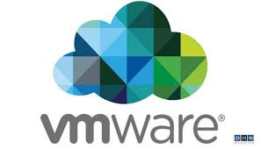

## 

## 

## 

# **VMWare Cloud**

VMWare Cloud Foundation takes VMware’s hyper-converged software-defined data center (SDCC) storage, CPU, and network components and combines it with the cloud. In this way, VMware technologies are pooled, virtualized, and made readily available in both on-prem and cloud-based deployments.

The SDDC can be deployed on-premises, in the public cloud, or in a hybrid cloud architecture. It offers deployment options for VMC on AWS, Azure and Google Cloud that run on bare-metal infrastructure belonging to each respective cloud provider.

This enables on-premises VMware workloads and VMware storage to extend to the cloud while continuing to use their existing on-premises VMware use cases. In this way, workloads can benefit from cloud-native services, such as Amazon Redshift, Amazon S3, Azure Analytics, Office 365, and Google Cloud’s machine learning and data analytics capabilities.

## **VMware Cloud Storage Challenges**

There are several challenges that come with using VMware Cloud:

* Complex migration: Migrating VMware workloads to the cloud can require complicated changes in application design and underlying architecture.
* High costs due to inflexible resource allocation: Compute, memory, and storage are all integrated within hyper-converged infrastructure (HCI) hosts. In workloads with large data sets, many HCI hosts will be required just to meet storage demands, with compute and memory over-provisioned.
* Limited storage capacity: Customers are limited to a total of 10.1 TiB of raw local storage per VSAN node. This storage space is further constrained by a mandatory amount of space required to remain unused and by Failure To Tolerate (FTT) settings.
* Data management support features: Enterprise deployments require additional data protection, high availability, and data replication features.

## **VMware Case Studies with Cloud Volumes ONTAP**

To help alleviate the challenges of operating in the cloud with VMware Cloud’s HCI, users can opt to deploy VMware Cloud with Cloud Volumes ONTAP as the data management layer for their public cloud resources.

Let’s take a look at some customer success stories to learn how Cloud Volumes ONTAP data management features address storage challenges.

## **Global Information Company “Lifts and Shifts” Workloads to VMware Cloud on AWS**

This company is a leading global information company that provides major industries and markets with analytics and solutions. It employs thousands of workers, including analysts, data scientists, and financial experts, and caters to multiple sectors worldwide such as energy, finance and transportation.

The company recently decided to migrate to the public cloud. This task was projected to take several years due to its 500 software products delivered to their customers. To accelerate this process, the company decided to lift and shift their workloads using VMware Cloud on AWS.

After migration, the company encountered challenges in managing its data. For example, although the company’s compute needs were modest, their large storage led to purchasing of unnecessary compute resources, because of VMC’s fixed storage to compute ratio.

The team began using Cloud Volumes ONTAP’s advanced storage capabilities to manage its data with greater flexibility at a lower cost. This helped them:

* Scale storage without affecting compute capacity.
* Seamlessly migrate with SnapMirror®.
* Simplify complex volume provisioning and file restoration processes into one-click operations.
* Automate storage workflows through Cloud Manger’s APIs.
* Back up unstructured data with Cloud Backup Service.

## **A Fujitsu Client Reduces Costs Substantially with a Flexible Configuration**

A Fortune 500 information technology giant, Fujitsu is the fourth-largest IT services provider in the world. It aids its clients with systems integration and managed services, and supports deployments on-premises, in the cloud, or in hybrid or multi-cloud architectures.

One of Fujitsu’s customers, a large financial company, has a sizable VMC on AWS deployment which was driving up costs. Fujitsu found an ideal solution for this problem in Cloud Volumes ONTAP.

Fujitsu incorporated a Cloud Volumes ONTAP AWS HA configuration into two VMware SDDCs, offloading hundreds of TBs of storage from the HCI used by VMware.

By using Cloud Volumes ONTAP, the company was able to:

* Access cloud-native AWS services such as EC2 and EBS directly and flexibly.
* Decouple and optimize compute and storage.
* Meet their business requirements while using 30% fewer VMC on AWS hosts.
* Reduce costs by $3 million over a three-year period.
* Ensure business continuity using the dual-instance high availability configuration.
* Replicate, sync, and protect all data to a secondary DR copy.

## **Enhanced Data Protection in the Cloud for a Personal Genomics and Biotechnology Company**

The privately held personal genomics and biotechnology company generates genetic reports about customer ancestry and genetic predispositions. Based on laboratory analysis of saliva samples, customers receive information about their ancestry composition, traits, maternal and paternal haplogroups, and can even use their genetic information to track down relatives.

The company wanted to improve the data protection of their VMware environments and NAS shares. In addition, it discovered that its AWS EBS storage costs were very high, and sought a way to reduce expenses.

By using Cloud Volumes ONTAP HA (high availability) for AWS, the company was able to successfully:

* Migrate 20TB to Cloud Volumes ONTAP.
* Dramatically reduce costs with Cloud Volumes ONTAP’s automatic data tiering capabilities and storage efficiency features.
* Data encryption in-transit with SnapMirror.
* Simplify off-site data protection with SnapMirror technology.

## **Migrating and Orchestrating Hybrid Cloud Architecture at the US Department of Energy**

The US Department of Energy runs a renewable energy lab that specializes in optimizing energy systems. Its R&D work drives innovation in transportation sustainability, efficient energy, and renewable sources of power, working with multiple governmental, industrial and academic institutions.

Using NetApp AFF and Cloud Volumes ONTAP, the lab established an all-flash tier for its mission-critical applications and VMware deployments, and seamlessly migrated workloads and backup to AWS. This hybrid architecture has led to several benefits, including:

* Backup is managed centrally through Cloud Manager’s single-pane interface.
* Backup time is reduced from 12 hours to 40 minutes.
* Rapid point-in-time data restoration with NetApp Snapshot™ technology.
* Lower storage costs with Cloud Volumes ONTAP built-in storage efficiency features.

## **A Final Note**

VMware Cloud is an excellent solution for hybrid and multi cloud architectures. However, its hyper-converged architecture limits storage space and ties it with compute resources. This hinders flexibility and can dramatically rack up cloud costs. In addition, VMware deployments can benefit from additional data management features such as backup, security, and high availability.

As these VMware Cloud case studies have shown, many companies have already applied Cloud Volumes ONTAP’s capabilities to their VMware deployments, improving their multicloud and hybrid architectures with considerable benefits such as enhanced performance, boosted automation, and lowered storage costs.

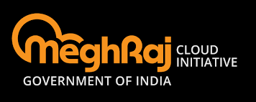

# **MEGHRAJ**

**Introduction**

In order to utilise and harness the benefits of Cloud Computing, Government of India has embarked upon an ambitious initiative - "GI Cloud" which has been named as "MeghRaj". The focus of this initiative is to accelerate delivery of e-services in the country while optimizing ICT spending of the Government. This will ensure optimum utilization of the infrastructure and speed up the development and deployment of eGov applications. The architectural vision of GI Cloud encompasses a set of discrete cloud computing environments spread across multiple locations, built on existing or new (augmented) infrastructure, following a set of common protocols, guidelines and standards issued by the Government of India. Two Policy reports viz., "GI Cloud Strategic Direction Paper" and "GI Cloud Adoption and Implementation Roadmap" have been prepared by Meity.

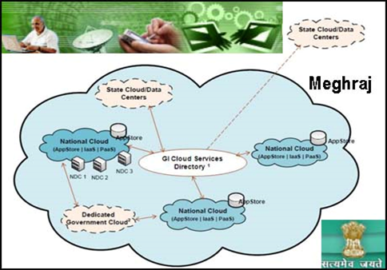

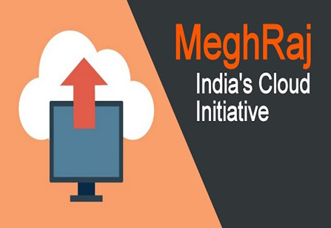

### **Advantages of GI Cloud**

* Optimum utilization of existing infrastructure
* Rapid deployment and reusability: Any software made available by any government of department in India can be made available to other departments as well without additional costs.
* Manageability and maintainability: It provides single point for maintaining Information & Communication Technology (ICT) infrastructure in India.
* Scalability: According to the demands from the citizens of India, infrastructure of the government can be increased accordingly.
* Efficient service delivery
* Security: A security framework for the entire GI Cloud will lead to less environmental complexity and less potential vulnerability.
* Increased user mobility
* Reduced effort in managing technology
* Ease of first time IT solution deployment
* Cost reduction
* Standardization: GI Cloud shall prescribe the standards around interoperability, integration, security, data security and portability etc.

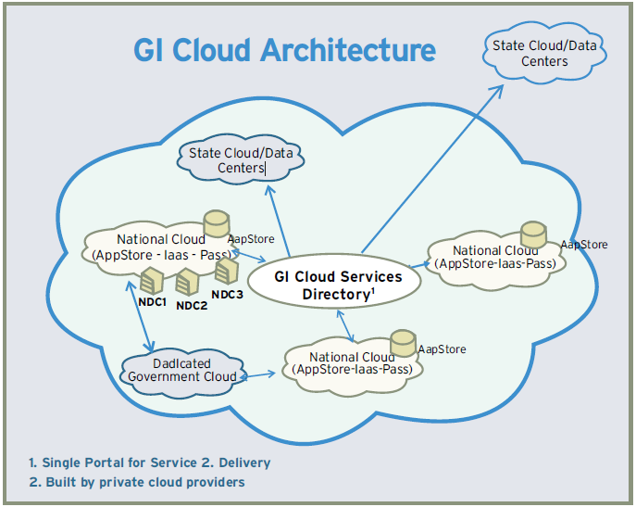

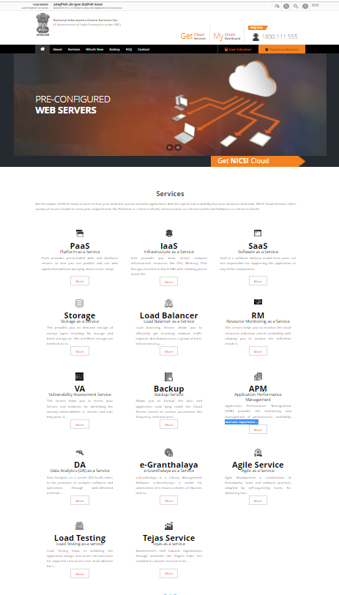

*Hands-on experience (Meghraj Home Page)*

### 

### **Services offered as part of National Cloud**

The National Informatics Centre (NIC) is providing National Cloud services under the initiative MeghRaj. The services offered are as follows.

#### Infrastructure as a Service (IaaS)

IaaS provides you basic virtual compute infrastructure resources like CPU, Memory, Disk Storage attached to blank VMs with allowing you to install OS, using ISOs, from scratch and customization. However you have to use your own licenses for OS and Application software (if any).

#### Platform as a Services (PaaS)

PaaS provides pre-installed web and database servers so that you can publish and run web application without worrying about server setup. The servers are pre configured ready with basic security hardening. Use PaaS service to quickly deploy servers and publish your web applications. The OS & Application Software licenses are provided by us as part of offering.

#### Software as a Services (SaaS)

This provides on demand software service. SaaS is a software delivery model where users are not responsible for supporting the application or any of the components. The server infrastructure, OS and software is being managed by cloud services. If you are having web application and want to distribute it to users, use our Cloud Service to deliver through Software as a Service.

#### 

#### Storage as a Service (STaaS)

STaaS provides need based storage solution . It provides excellent alternative to the traditional on-site and dedicated storage systems and reduces the complexities of deploying and managing multiple storage tiers. You can use it to mitigate risks in disaster recovery, provide long-term retention for records and enhance both continuity and availability.

Load Balancer as a Service :  
Load balancing Service allows you to efficiently get incoming network traffic requests distributed across a group of back-end servers (e.g. server farm / server pool). This service is available on demand for critical application requiring high availability and easy workload manageability.[.](https://cloud.nicsi.nic.in/services_lb.php)

Resource Monitoring as a Service :  
This service helps you to monitor the cloud resources utilization and its availability with allowing you to analyse the utilization trends for critical server resources like CPU, Memory, Network I/O etc. This helps you for better capacity planning and provide a better end-user experience. 

Vulnerability Assessment Service :  
This service helps you to assess your Servers and networks for identifying the security vulnerabilities i.e. threats and risks they pose. A vulnerability assessment process detects and classifies system weaknesses in Servers, networks and communications equipment and predicts the effectiveness of countermeasures.

Backup Service :  
Allows you to backup the data and application code lying inside the Cloud Servers based on various parameters like frequency, retention period etc.

Application Performance Management (APM) Service :  
Application Performance Management (APM) provides the monitoring and management of performance, availability and user experience of software applications. APM strives to detect and diagnose complex application performance problems to maintain an expected level of service.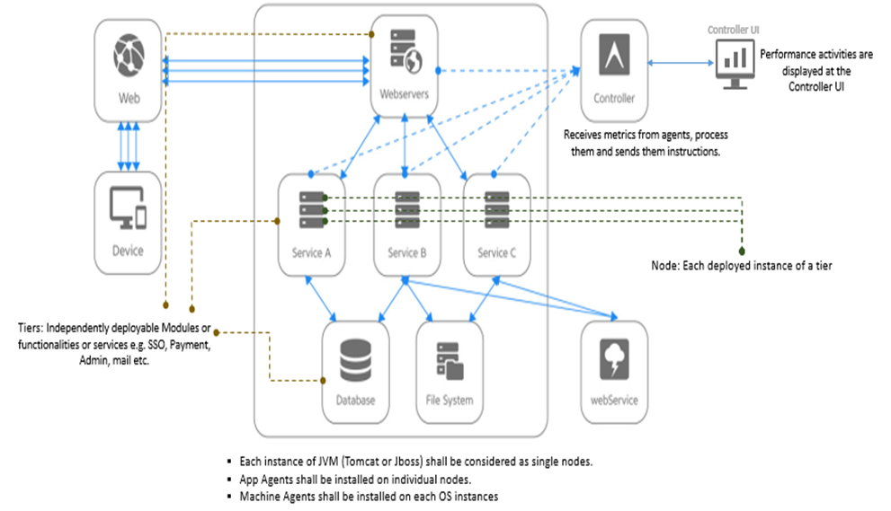

Data Analytics (DA) as a Service :  
Data Analytics as a service (DA-SaaS) refers to the provision of analytics software and operations through web-delivered technologies. These types of solutions offer businesses an alternative to developing internal hardware setups just to perform business analytics.

Agile as a Service :  
Agile development is combination of frameworks, tools and software practices adopted by self-organizing teams for delivering fast paced user centric software solutions. Practices and frameworks touch upon all the aspects of software development from planning (Scrum) to deployment and monitoring (DevOps).

Load Testing as a service :  
Load Testing helps in validating the application design and server infrastructure for expected concurrent user load wherein the system’s response is tested under varying load conditions simulating concurrent virtual users accessing the application under test.

Public IP Service :  
A public IP address is an IP address that can be allocated to any of your application on cloud server to make it accessed over the Internet.

Anti-virus Service :  
Virus protection is an important part of keeping the systems, applications and data in your cloud environment safe from viruses, spyware nd other malware threats. Antivirus service is made available to cloud users as Managed Service

Web Application Firewall (WAF) Service :  
Web Application Firewall will help you to give extra protection for HTTP / web based applications with having applied a set of rules to an HTTP conversation and cover common attacks such as cross-site scripting (XSS) and SQL injection.